**A**

**MST Practical Activity Report**

**Submitted for**

**ENGINEERING DESIGN-II (UTA024)**

**Submitted by:**

**(102103017)Dixant Kumar**

**(102103268)Jeetesh Rajpal**

**(102103267)Pulkit Arora**

**(102103266)Jagdish Agarwal**

**(102103269)Janardhan Singh Jadon**

**BE Second Year**

**Batch:2COE10**

Submitted to-

**Dr. Ashutosh Mishra**



**Computer Science and Engineering Department**

**TIET, Patiala**

**Jan-June 2023**

**TABLE OF CONTENTS**

|  |  |
| --- | --- |
| **ABSTRACT** | i |
| **DECLARATION** | ii |
| **TABLE OF CONTENTS** | iii |
|  |  |
|  |  |
|  |  |
|  |  |

**ABSTRACT**

The Following project consists of the experiments Conducted in the CSED lab under the guidance of Mr. Ashutosh Mishra for the engineering design project (UTA-024) Subject.

This report contains the use of Arduino Uno to perform various experiments. We used Arduino IDE software to write different codes related to different experiments. We used breadboard, LEDs, probe/connecting wires, and Arduino UNO to make the circuits and executed the codes to see the results.

**DECLARATION**

We hereby declare that the project work entitled “ENGINEERING DESIGN” submitted to Thapar Institute of Engineering and Technology, Patiala is a record of group effort done under the guidance of:

Dr. Ashutosh Mishra

**Computer Science and Engineering Department, Thapar Institute of Engineering and Technology, Patiala**

|  |  |  |  |  |  |  |  |  |  |  |  |  |  |  |  |  |  |  |  |  |  |  |  |  |  |  |  |  |  |  |  |  |  |  |  |  |  |
| --- | --- | --- | --- | --- | --- | --- | --- | --- | --- | --- | --- | --- | --- | --- | --- | --- | --- | --- | --- | --- | --- | --- | --- | --- | --- | --- | --- | --- | --- | --- | --- | --- | --- | --- | --- | --- | --- |
| **INDEX**   |  |  |  | | --- | --- | --- | | S. No. | Name of Experiments | Page No. | | 1. | Introduction to Arduino Microcontroller | 7 | | 2. | Write a program in Arduino to blink a LED.  a. Single LED  b. Multiple LEDs | 9 | | 3. | Write a Arduino program to design and simulate both forward and reverse pattern (1, 2, 3, 4, 5 ) sequence for different color LEDs using following function:  a. delay()  b. for ()  Also, mention the effect on intensity of LEDs based on variation in different resistance values e.g, R=200Ω, 200pΩ, 200kΩ. | 11 | | 4. | Write a Arduino program to design and simulate forward pattern (3, 2, 5, 1,4) and reverse pattern (2, 5, 4, 1, 3) sequence for different color LEDs using following function:  a. delay()  b. for () | 18 | |  | **SERIAL COMMUNICATION** |  | | 5. | Q. WAP for following pattern using for loop (as per requirement) **********************************************  Roll No. ______________________________________ *****************************  Name: ________________________________________ *************************************** Branch:_______________________________________ ********************************* | 26 | | 6. | WAP for dimmer (Change in intensity of single LED bulb) using i. digitalRead()  ii. analogRead() | 29 | | 7. | WAP to change the intensity of the LEDs sequence 35214 in both forward and reverse order. (Hint: Lowest LED number will have the least intensity and intensity will gradually increase as per the LED number and LED 5 must have maximum intensity) | 31 | | 8. | Using Serial Monitor as user input:  WAP to change the intensity of the 5 LEDs for sequence 12345 using any control statements. | 34 | | 9. | WAP in Arduino to control the brightness of an LED. The intensity of the LED should be changed based on the values provided by the serial input. | 36 | | 10. | WAP in Arduino to control the brightness of the LED, for each of the following ranges in value from 0 to 255 and the corresponding LED should glow for the respective range.  0-50 Blue  51-100 Yellow  101-150 Green  151-200 Red  201-255 Orange | 38 |   **EXPERIMENT-1**  **1. OBJECTIVE:** Introduction to Arduino Microcontroller |  |
| **2. HARDWARE USED:** Arduino Uno board |  |
| **3. SOFTWARE USED:** Arduino IDE |  |
| **4. THEORY:**  Arduino UNO is a microcontroller board based on the **ATmega328P**. It has 14 digital input/output pins (of which 6 can be used as PWM outputs), 6 analog inputs, a 16 MHz ceramic resonator, a USB connection, a power jack, an ICSP header and a reset button. It contains everything needed to support the microcontroller; simply connect it to a computer with a USB cable or power it with a AC-to-DC adapter or battery to get started. Along with ATmega328P, it consists other components such as crystal oscillator, serial communication, voltage regulator, etc. to support the microcontroller.  **5. LOGIC/CIRCUIT DIAGRAM :**  **6.RESULT ANALYSIS :**  Learned about the Arduino Board, its Pinout diagram and the different components in the board, the Arduino IDE software and how it can be used to perform different functions.  Arduino Uno combined with Arduino IDE is intermediator between software and the Arduino hardware (ATMEGA 328P). |  |
|  |  |
| **Signature of Faculty member** |  |

**EXPERIMENT-2**

**1. OBJECTIVE:** Write a program in Arduino to blink a LED:

a. Single LED

**2. HARDWARE USED:**

|  |  |  |
| --- | --- | --- |
| **Sr. No** | **Name of Components** | **Value** |
| 1. | Resistor (1) | 220 Ω |
| 2. | Light Emitting Diode (1) | Green |
| 3. | Arduino Uno R3 (1) | NA |
| 4. | Breadboard (1) | NA |
| 5. | Connecting Wires (2) | NA |

**3. SOFTWARE USED:** Arduino IDE

**4. THEORY: A**n LED is an electronic component and stands for Light Emitting Diode. It is a small light which has a very low power consumption. The Arduino has one built in LED which is internally connected to digital pin 13.

**5. LOGIC/CIRCUIT DIAGRAM:**

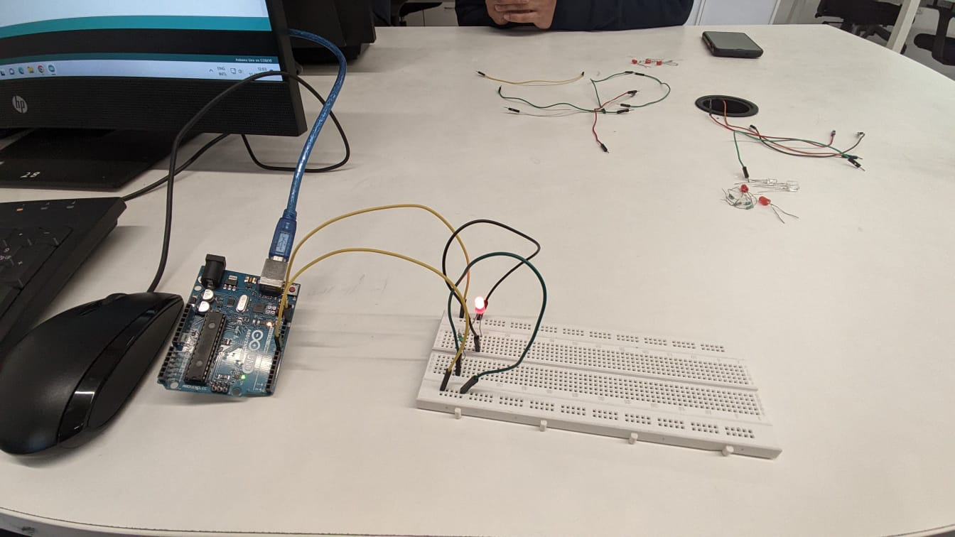

**CODE:**

|  |
| --- |
| **void setup()**  **{**  **pinMode(8, OUTPUT);**  **}**  **void loop()**  **{**  **digitalWrite(8, HIGH);**  **delay(1000);**  **digitalWrite(8, LOW);**  **delay(1000);**  **}** |

**6. RESULT ANALYSIS:**

In this experiment, we have learnt how we can select the pin of an Arduino board and set it HIGH or LOW depending upon the usage. The delay time between the transition for the desired Interval time could be select while giving the command.

**1. OBJECTIVE:** Write a program in Arduino to blink a LED:

b. Multiple LEDs

**2. HARDWARE USED:**

|  |  |  |
| --- | --- | --- |
| **Sr. No** | **Name of Components** | **Value** |
| 1. | Resistor (5) | 100 Ω |
| 2. | Light Emitting Diode (5) | Red |
| 3. | Arduino Uno R3 (1) | NA |
| 4. | Breadboard (1) | NA |
| 5. | Connecting Wires | NA |

**3. SOFTWARE USED:** Arduino IDE

**4. THEORY: A**n LED is an electronic component and stands for Light Emitting Diode. It is a small light which has a very low power consumption. The Arduino has one built in LED which is internally connected to digital pin 13.

**5. LOGIC/CIRCUIT DIAGRAM:**

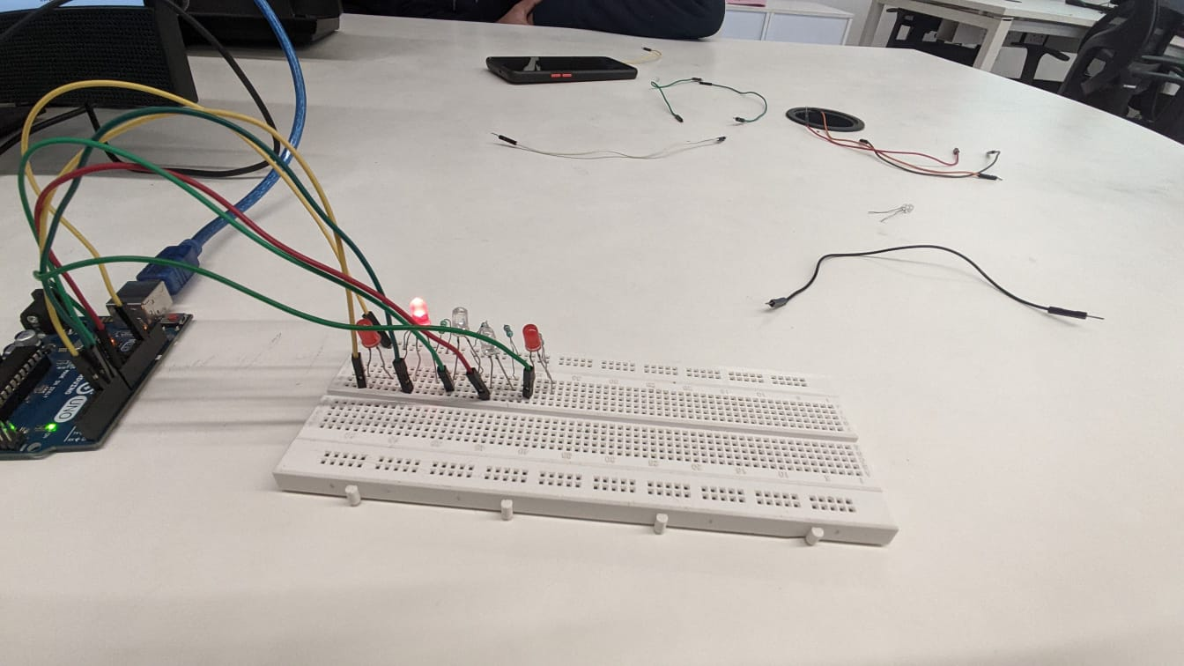

**CODE:**

void setup()

{

pinMode(13, OUTPUT);

pinMode(11, OUTPUT);

}

void loop()

{

digitalWrite(13,HIGH);

digitalWrite(11,LOW);

delay(1000);

digitalWrite(13,LOW);

digitalWrite(11,HIGH);

delay(1000);

}

**EXPERIMENT-3**

**1. OBJECTIVE:** Write a Arduino program to design and simulate both forward and reverse pattern (1, 2, 3, 4, 5) sequence for different LEDs using following function:

a. delay ()

b. for ()

Also, mention the effect on intensity of LEDs based on variation in different resistance values e.g, R=200Ω, 200pΩ, 200kΩ.

**2. HARDWARE USED:** 1 × Breadboard

1 × Arduino Uno R3

5 × LED

5 × 220Ω Resistor

**3. SOFTWARE USED: Arduino IDE**

**4. THEORY:**

In this experiment, we will try to make different color LEDs blink in both forward and reverse case. We will also see the effect of different resistances on the intensity of the light in LED. We will make use of Arduino board to make the circuit work by running the code set up.

**5. LOGIC/CIRCUIT DIAGRAM:**

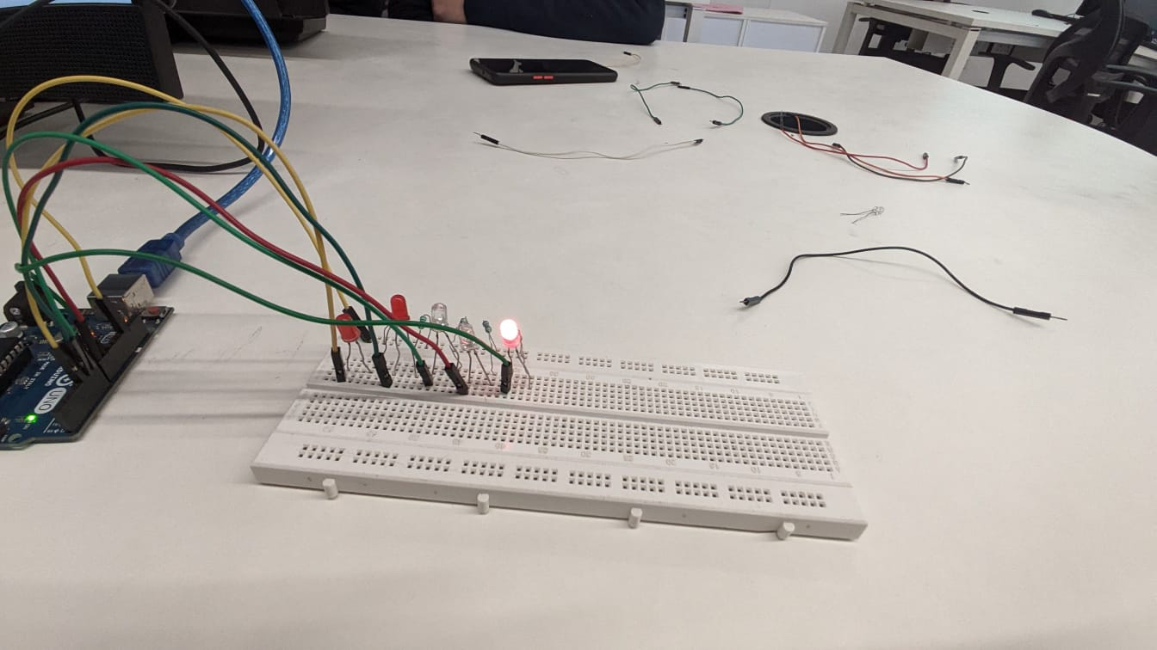

**delay()**

|  |
| --- |
| **void setup() {**  **// put your setup code here, to run once:**  **pinMode(3,OUTPUT);**  **pinMode(4,OUTPUT);**  **pinMode(5,OUTPUT);**  **pinMode(6,OUTPUT);**  **pinMode(7,OUTPUT);**  **}**  **void loop() {**  **// put your main code here, to run repeatedly:**  **digitalWrite(5,HIGH);**  **delay(1000);**  **digitalWrite(5,LOW);**  **delay(1000);**  **digitalWrite(5,HIGH);**  **delay(1000);**  **digitalWrite(5,LOW);**  **delay(1000);**  **digitalWrite(5,HIGH);**  **delay(1000);**  **digitalWrite(5,LOW);**  **delay(1000);**  **digitalWrite(3,HIGH);**  **delay(1000);**  **digitalWrite(3,LOW);**  **delay(1000);**  **digitalWrite(4,HIGH);**  **delay(1000);**  **digitalWrite(4,LOW);**  **delay(1000);**  **digitalWrite(4,HIGH);**  **delay(1000);**  **digitalWrite(4,LOW);**  **delay(1000);**  **digitalWrite(7,HIGH);**  **delay(1000);**  **digitalWrite(7,LOW);**  **delay(1000);**  **digitalWrite(7,HIGH);**  **delay(1000);**  **digitalWrite(7,LOW);**  **delay(1000);**  **digitalWrite(7,HIGH);**  **delay(1000);**  **digitalWrite(7,LOW);**  **delay(1000);**  **digitalWrite(7,HIGH);**  **delay(1000);**  **digitalWrite(7,LOW);**  **delay(1000);**  **digitalWrite(7,HIGH);**  **delay(1000);**  **digitalWrite(7,LOW);**  **delay(1000);**  **digitalWrite(6,HIGH);**  **delay(1000);**  **digitalWrite(6,LOW);**  **delay(1000);**  **digitalWrite(6,HIGH);**  **delay(1000);**  **digitalWrite(6,LOW);**  **delay(1000);**  **digitalWrite(6,HIGH);**  **delay(1000);**  **digitalWrite(6,LOW);**  **delay(1000);**  **digitalWrite(6,HIGH);**  **delay(1000);**  **digitalWrite(6,LOW);**  **delay(1000);**  **// Reverse**  **digitalWrite(6,HIGH);**  **delay(1000);**  **digitalWrite(6,LOW);**  **delay(1000);**  **digitalWrite(6,HIGH);**  **delay(1000);**  **digitalWrite(6,LOW);**  **delay(1000);**  **digitalWrite(6,HIGH);**  **delay(1000);**  **digitalWrite(6,LOW);**  **delay(1000);**  **digitalWrite(6,HIGH);**  **delay(1000);**  **digitalWrite(6,LOW);**  **delay(1000);**  **digitalWrite(5,HIGH);**  **delay(1000);**  **digitalWrite(5,LOW);**  **delay(1000);**  **digitalWrite(5,HIGH);**  **delay(1000);**  **digitalWrite(5,LOW);**  **delay(1000);**  **digitalWrite(5,HIGH);**  **delay(1000);**  **digitalWrite(5,LOW);**  **delay(1000);**  **digitalWrite(4,HIGH);**  **delay(1000);**  **digitalWrite(4,LOW);**  **delay(1000);**  **digitalWrite(4,HIGH);**  **delay(1000);**  **digitalWrite(4,LOW);**  **delay(1000);**  **digitalWrite(7,HIGH);**  **delay(1000);**  **digitalWrite(7,LOW);**  **delay(1000);**  **digitalWrite(7,HIGH);**  **delay(1000);**  **digitalWrite(7,LOW);**  **delay(1000);**  **digitalWrite(7,HIGH);**  **delay(1000);**  **digitalWrite(7,LOW);**  **delay(1000);**  **digitalWrite(7,HIGH);**  **delay(1000);**  **digitalWrite(7,LOW);**  **delay(1000);**  **digitalWrite(7,HIGH);**  **delay(1000);**  **digitalWrite(7,LOW);**  **delay(1000);**  **digitalWrite(3,HIGH);**  **delay(1000);**  **digitalWrite(3,LOW);**  **delay(1000);**  **}** |

**for()**

|  |
| --- |
| **void setup() {**  **// put your setup code here, to run once:**  **pinMode(9,OUTPUT);**  **pinMode(10,OUTPUT);**  **pinMode(11,OUTPUT);**  **pinMode(12,OUTPUT);**  **pinMode(13,OUTPUT);**  **}**  **void loop() {**  **// put your main code here, to run repeatedly:**  **for(int i=9;i<14;i++)**  **{**  **digitalWrite(i,HIGH);**  **delay(1000);**  **digitalWrite(i,LOW);**  **}**  **for(int i=14;i>8;i--)**  **{**  **digitalWrite(i,HIGH);**  **delay(1000);**  **digitalWrite(i,LOW);**  **}**  **delay(20);**  **}** |

**6. RESULT ANALYSIS:**

In this experiment, we learnt how to make some number of LED blink in certain pattern.

We learnt how to use for loop to make the code very efficient. We also learnt and used delay() function.

**EXPERIMENT-4**

**1. OBJECTIVE:** Write an Arduino program to design and simulate forward pattern (3,2,5,1,4) and reverse pattern (2,5,4,1,3) sequence for LEDs using following function:

1. delay()
2. for()

**2. HARDWARE USED:** 1 × Breadboard

1 × Arduino Uno R3

5 × LED

5 × 220Ω Resistor

**3. SOFTWARE USED:** Arduino IDE

**4. THEORY:**

In this experiment, we have designed a circuit and code to simulate forward pattern for LEDs on pin number (3,2,5,1,4) and reverse pattern for LEDs on pin number (2,5,4,1,3). We have used delay() and for() functions for running the code and making the LEDs blink in the random pattern given. We have made use of 5 different color LEDs and Arduino boards, description of which is give above.

**5. LOGIC/CIRCUIT DIAGRAM:**

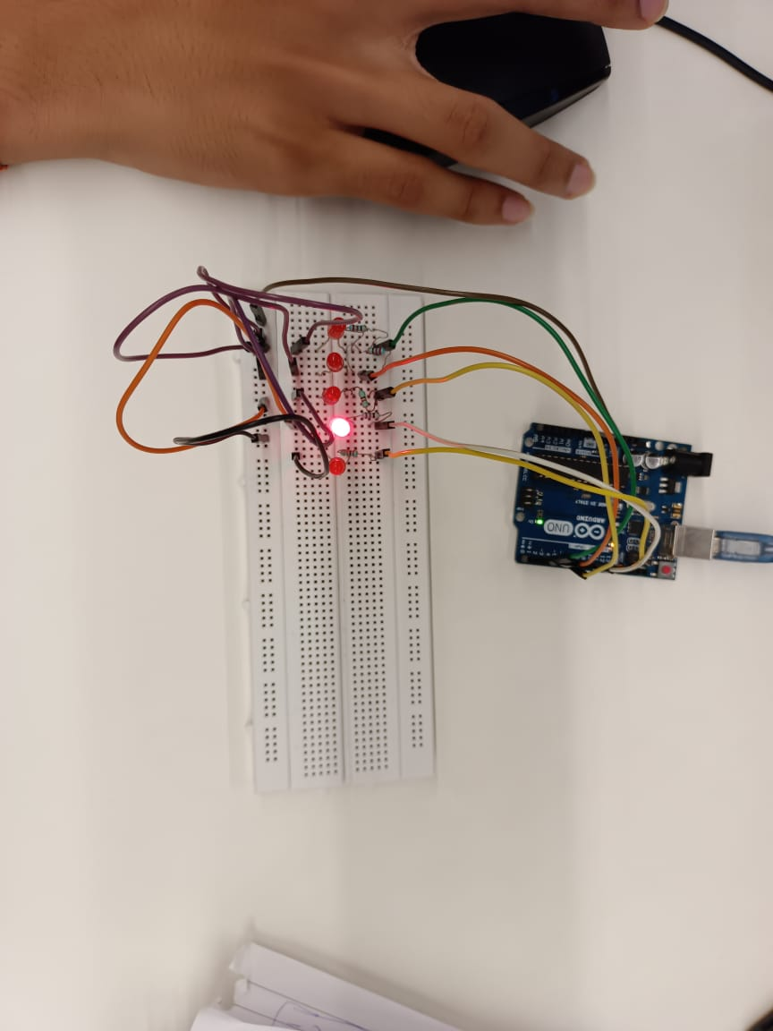

**delay()**

|  |
| --- |
| **void setup() {**  **// put your setup code here, to run once:**  **pinMode(3,OUTPUT);**  **pinMode(4,OUTPUT);**  **pinMode(5,OUTPUT);**  **pinMode(6,OUTPUT);**  **pinMode(7,OUTPUT);**  **}**  **void loop() {**  **// put your main code here, to run repeatedly:**  **digitalWrite(5,HIGH);**  **delay(1000);**  **digitalWrite(5,LOW);**  **delay(1000);**  **digitalWrite(5,HIGH);**  **delay(1000);**  **digitalWrite(5,LOW);**  **delay(1000);**  **digitalWrite(5,HIGH);**  **delay(1000);**  **digitalWrite(5,LOW);**  **delay(1000);**  **digitalWrite(3,HIGH);**  **delay(1000);**  **digitalWrite(3,LOW);**  **delay(1000);**  **digitalWrite(4,HIGH);**  **delay(1000);**  **digitalWrite(4,LOW);**  **delay(1000);**  **digitalWrite(4,HIGH);**  **delay(1000);**  **digitalWrite(4,LOW);**  **delay(1000);**  **digitalWrite(7,HIGH);**  **delay(1000);**  **digitalWrite(7,LOW);**  **delay(1000);**  **digitalWrite(7,HIGH);**  **delay(1000);**  **digitalWrite(7,LOW);**  **delay(1000);**  **digitalWrite(7,HIGH);**  **delay(1000);**  **digitalWrite(7,LOW);**  **delay(1000);**  **digitalWrite(7,HIGH);**  **delay(1000);**  **digitalWrite(7,LOW);**  **delay(1000);**  **digitalWrite(7,HIGH);**  **delay(1000);**  **digitalWrite(7,LOW);**  **delay(1000);**  **digitalWrite(6,HIGH);**  **delay(1000);**  **digitalWrite(6,LOW);**  **delay(1000);**  **digitalWrite(6,HIGH);**  **delay(1000);**  **digitalWrite(6,LOW);**  **delay(1000);**  **digitalWrite(6,HIGH);**  **delay(1000);**  **digitalWrite(6,LOW);**  **delay(1000);**  **digitalWrite(6,HIGH);**  **delay(1000);**  **digitalWrite(6,LOW);**  **delay(1000);**  **// Reverse**  **digitalWrite(6,HIGH);**  **delay(1000);**  **digitalWrite(6,LOW);**  **delay(1000);**  **digitalWrite(6,HIGH);**  **delay(1000);**  **digitalWrite(6,LOW);**  **delay(1000);**  **digitalWrite(6,HIGH);**  **delay(1000);**  **digitalWrite(6,LOW);**  **delay(1000);**  **digitalWrite(6,HIGH);**  **delay(1000);**  **digitalWrite(6,LOW);**  **delay(1000);**  **digitalWrite(5,HIGH);**  **delay(1000);**  **digitalWrite(5,LOW);**  **delay(1000);**  **digitalWrite(5,HIGH);**  **delay(1000);**  **digitalWrite(5,LOW);**  **delay(1000);**  **digitalWrite(5,HIGH);**  **delay(1000);**  **digitalWrite(5,LOW);**  **delay(1000);**  **digitalWrite(4,HIGH);**  **delay(1000);**  **digitalWrite(4,LOW);**  **delay(1000);**  **digitalWrite(4,HIGH);**  **delay(1000);**  **digitalWrite(4,LOW);**  **delay(1000);**  **digitalWrite(7,HIGH);**  **delay(1000);**  **digitalWrite(7,LOW);**  **delay(1000);**  **digitalWrite(7,HIGH);**  **delay(1000);**  **digitalWrite(7,LOW);**  **delay(1000);**  **digitalWrite(7,HIGH);**  **delay(1000);**  **digitalWrite(7,LOW);**  **delay(1000);**  **digitalWrite(7,HIGH);**  **delay(1000);**  **digitalWrite(7,LOW);**  **delay(1000);**  **digitalWrite(7,HIGH);**  **delay(1000);**  **digitalWrite(7,LOW);**  **delay(1000);**  **digitalWrite(3,HIGH);**  **delay(1000);**  **digitalWrite(3,LOW);**  **delay(1000);**  **}** |

**for()**

|  |
| --- |
| **void setup() {**  **pinMode(3, OUTPUT);**  **pinMode(4, OUTPUT);**  **pinMode(5, OUTPUT);**  **pinMode(6, OUTPUT);**  **pinMode(7, OUTPUT);**  **}**  **void loop()**  **{**  **// Pattern 3 1 2 5 4**  **int pattern[] = {3,1,2,5,4};**  **int arr[]={5,3,4,7,6};**  **for (int j = 0; j<5;j++)**  **{**  **for (int i = 1; i<=pattern[j] ; i++)**  **{**  **digitalWrite(arr[j],HIGH);**  **delay(100);**  **digitalWrite(arr[j],LOW);**  **delay(100);**  **}**  **}**  **delay (2000);**  **//Reverse pattern - 4 3 2 5 1**  **int pattern_rev[]={4,3,2,5,1};**  **for (int j = 0; j<5;j++)**  **{**  **for (int i = 1; i<=pattern_rev[j] ; i++)**  **{**  **digitalWrite(arr[j],HIGH);**  **delay(100);**  **digitalWrite(arr[j],LOW);**  **delay(100);**  **}**  **}**  **}** |

**6. RESULT ANALYSIS:**

In this experiment, we learnt how to blink some number of LED in certain pattern. We used for() loop and made arrays to make the task easy and the code more efficient.

**EXPERIMENT-5**

**1. OBJECTIVE:** Serial communications:

Serial.begin(9600);

Serial.print();

Serial.println();

Serial.Read()

Serial.write()

Program for pattern using for loop

****************************************

Roll No.________________________

***********************

Name:_____________________

**********************************

Branch:________________________

*****************************

**2. HARDWARE USED:**1 × Arduino Uno R3

3. **SOFTWARE USED:** Arduino IDE

**4. THEORY:**

In this experiment we will learn about the functions:

Serial.begin(9600);

Serial.print();

Serial.println();

Serial.Read()

Serial.write()

The 9600 used in Serial.begin means that this starts the serial communication, so that the Arduino can send out commands through the USB connection. The value 9600 is called the ‘baud rate’ of the connection. This is how fast the data is to be sent.

The serial.print() function prints the text in the output window.

Serial.println() function prints the text in the next line.

Serial.Read() reads the text you provide as an input in the output window while serial.write() writes the given input on the output window.

**5. LOGIC/CIRCUIT DIAGRAM:**

|  |
| --- |
| **void setup() {**  **// put your setup code here, to run once:**  **Serial.begin(9600);**  **long int roll = 102103267;**  **String Name = "Pulkit";**  **String branch = "CO10";**  **for(int i = 0;i<45;i++)**  **{**  **Serial.print("*");**  **}**  **Serial.println("");**  **Serial.print("Roll Number: ");**  **Serial.println(roll);**    **for(int j = 0;j<37;j++)**  **{**  **Serial.print("*");**  **}**  **Serial.println("");**  **Serial.print("Name: ");**  **Serial.println(Name);**  **for(int k = 0;k<43;k++)**  **{**  **Serial.print("*");**  **}**  **Serial.println("");**  **Serial.print("Branch: ");**  **Serial.println(branch);**  **for(int l = 0;l<67;l++)**  **{**  **Serial.print("*");**  **}**  **}**  **void loop() {**  **// put your main code here, to run repeatedly**  **}** |

**6. RESULT ANALYSIS:**

In this experiment, we learnt some code to communicate information to print information on serial monitor. This can be helpful to print important data from Arduino to serial monitor.

**EXPERIMENT-6**

1. **OBJECTIVE:** Write an Arduino Program for dimmer (Change in intensity of single LED bulb) using
2. digitalRead ()
3. analogRead ()
4. **HARDWARE USED:** 1 × Arduino Uno R3

1 × Breadboard

1 × LED

1 × 220Ω Resistor

1. **SOFTWARE USED:** Arduino IDE
2. **THEORY:**

In this experiment, we have designed a circuit and code to simulate intensity for LED on pin number (3). We have used Serial.print() to take the input from user, digitalRead() and analogRead() functions for running the code and making the LED blink with the given intensity. We have made use of LED and Arduino board, description of which is give above.

1. **LOGIC/CIRCUIT DIAGRAM:**

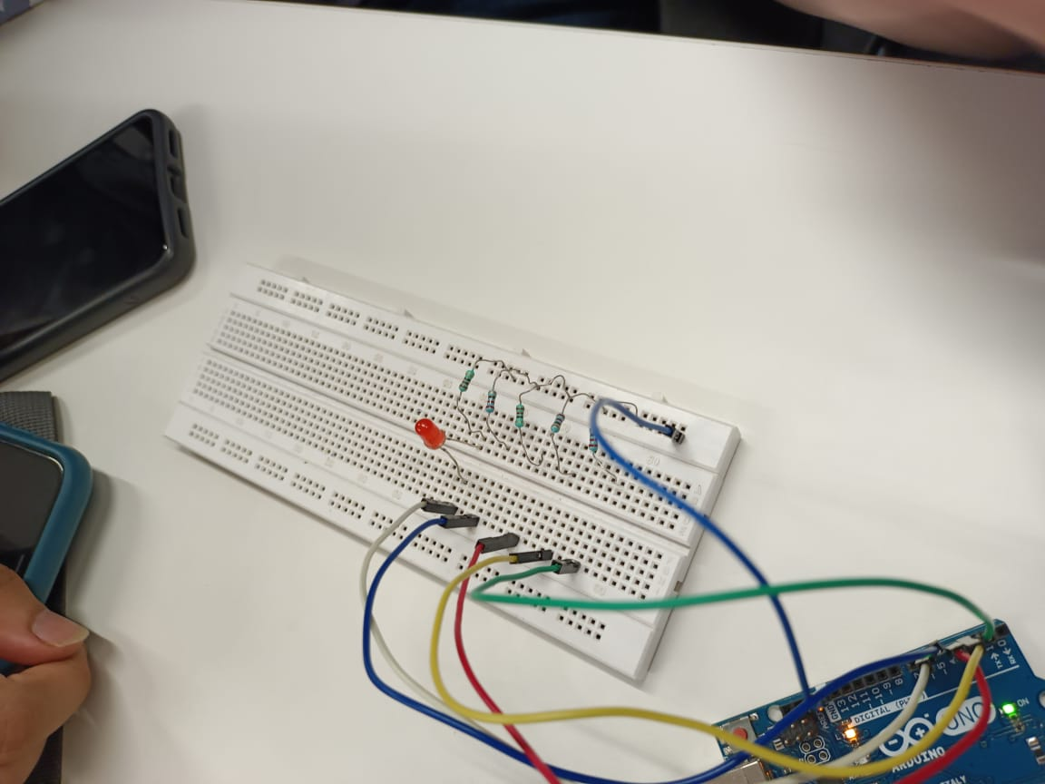

**void setup(){**

**Serial.begin(9600);**

**pinMode(5,OUTPUT);**

**}**

**void loop() {**

**int a;**

**a=Serial.parseInt();**

**Serial.print(a);**

**analogWrite(5,a);**

**delay(1000);**

**}**

1. **RESULT ANALYSIS:**

In this experiment, we learnt how to change the intensity of LED brightness. We learnt about Arduino’s PWM pins, which works in changing the brightness of LED. We took input from serial monitor and changed the brightness.

**EXPERIMENT-7**

1. **OBJECTIVE:** Write an Arduino Program to change the intensity of the given LEDs for the sequence 35214 in for both forward and reverse order.
2. **HARDWARE USED:** 1 × Arduino Uno R3

1 × Breadboard

5 × LED

5 × 220Ω Resistor

1. **SOFTWARE USED:** Arduino IDE
2. **THEORY:** In this experiment, we have designed a circuit and code to simulate intensity of LEDs in forward pattern on pin number (3,5,9,10,11) and reverse pattern for LEDs on pin number (3,5,9,10,11). We have used Serial.print() to take the input from user and analogWrite() functions for running the code and making the LEDs blink with the input intensity. We have made use of 5 different LEDs and Arduino board, description of which is give above.
3. **LOGIC/CIRCUIT DIAGRAM**

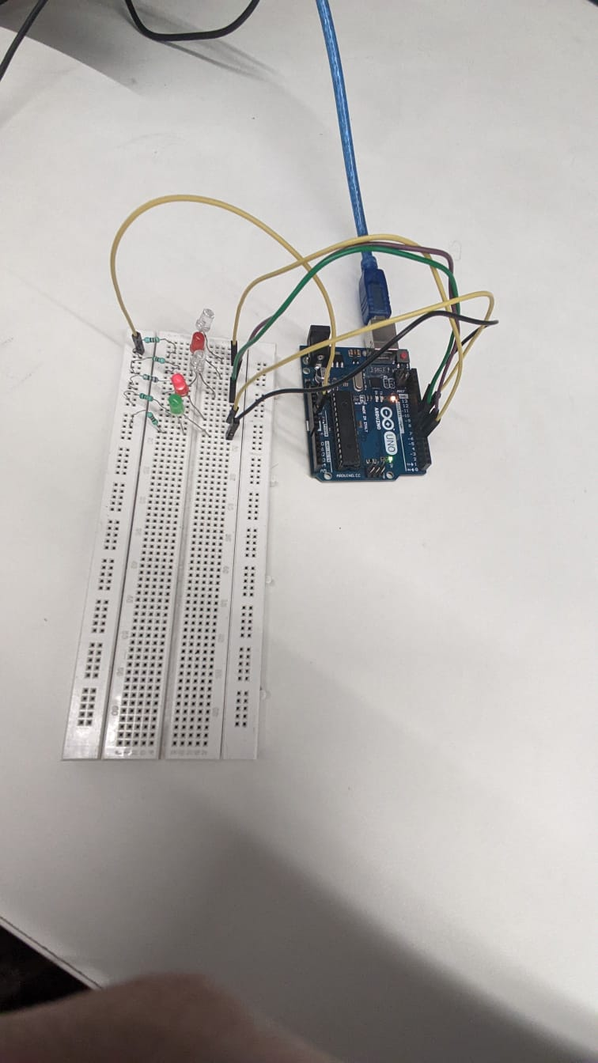

**CODE:**

|  |
| --- |
| **void setup() {**  **Serial.begin(9600);**  **pinMode (8,OUTPUT);**  **pinMode (9,OUTPUT);**  **pinMode (6,OUTPUT);**  **pinMode (5,OUTPUT);**  **pinMode (3,OUTPUT); }**  **void loop() {**  **//for led 3**  **for (i=0;i<=255;i+=15)**  **{ analogWrite(6,i); delay(200); }**  **for(i=255;i>=0;i-=15)**  **{ analogWrite(6,i); delay(200); }**  **//for led 5**  **for (i=0;i<=255;i+=15)**  **{ analogWrite(3,i); delay(200); }**  **for(i=255;i>=0;i-=15)**  **{ analogWrite(3,i); delay(200); }**  **//for led 2**  **for (i=0;i<=255;i+=15)**  **{ analogWrite(9,i); delay(200); }**  **for(i=255;i>=0;i-=15)**  **{ analogWrite(9,i);**  **delay(100); } //for led 1**  **int count=0;**  **for (i=0;i<=255;i+=15)**  **{ analogWrite(8,i);**  **delay(200); }**  **for(i=255;i>=0;i-=15)**  **{ analogWrite(8,i);**  **delay(200); }**  **//for led 4**  **for (i=0;i<=255;i+=15)**  **{ analogWrite(5,i);**  **delay(200); }**  **for(i=255;i>=0;i-=15)**  **{ analogWrite(5,i);**  **delay(200); }**  **}** |

1. **RESULT ANALYSIS:**

In this experiment, we learnt how to change the intensity of LED in certain order.

**EXPERIMENT-8**

**1. OBJECTIVE:** WAP to change the intensity of the 5 LEDs for sequence 12345 using any control statements.

**2.HARDWARE USED:** Arduino UNO, breadboard, connecting/probe wires, LEDs.

**3.SOFTWARE USED:** Arduino (Integrated Development Environment)

**4.THEORY:** In this Experiment 5 LED’s are made to glow in a certain pattern (1,2,3,4,5).We use analogWrite() function to write on the analog pins  
analogWrite() : Writes an analog value (PWM wave) to a pin. Can be used to light a LED at varying brightness

**5. LOGIC/CIRCUIT DIAGRAM:**

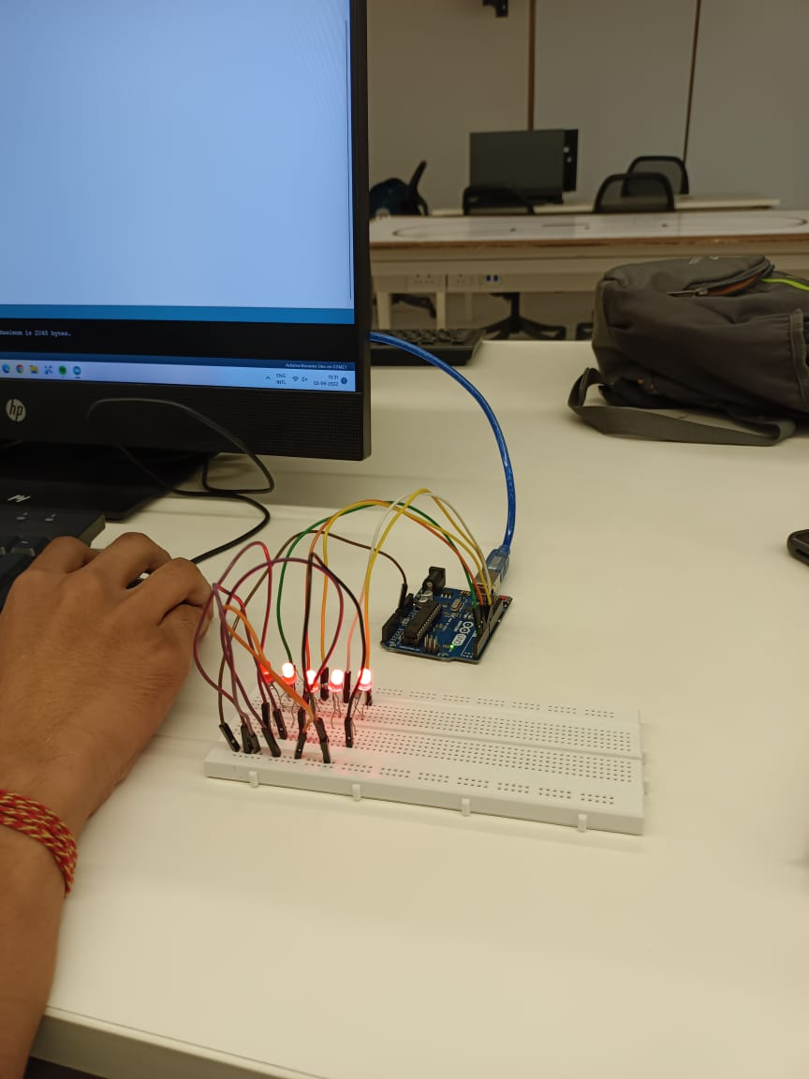

|  |
| --- |
| **void setup() {**  **// put your setup code here, to run once:**  **Serial.begin(9600);**  **}**  **void lightitup(int k,int j)**  **{**  **while(j>0)**  **{**  **pinMode(k,OUTPUT);**  **analogWrite(k,HIGH);**  **delay(700);**  **analogWrite(k,LOW);**  **delay(700);**  **j=j-1;**  **}**  **}**  **void loop() {**  **// put your main code here, to run repeatedly:**  **int j=Serial.parseInt();**  **for (j;j>0;j--)**  **{**  **int arr[5]={1,2,3,4,5};**  **int arr_pos[5]={3,2,4,5,1};**  **for(int i=0;i<5;i++)**  **{**  **lightitup(arr[i],arr_pos[i]);**  **}**  **int arr_rev[5]={11,12,8,9,10};**  **int arr_pos_rev[5]={4,5,1,2,3};**  **for(int i=0;i<5;i++)**  **{**  **lightitup(arr_rev[i],arr_pos_rev[i]);**  **}**  **}**  **}** |

**6. RESULT ANALYSIS:**

In this experiment, we learnt how to change the intensity of LED using control statement.

**EXPERIMENT-9**

1. **OBJECTIVE:** Write an Arduino Program to control the brightness of the LED. The intensity of the LED should be changed based on the values provided by the serial input.
2. **HARDWARE USED:** 1 × Arduino Uno R3

1 × Breadboard

5 × LED

5 × 220Ω Resistor

1. **SOFTWARE USED:** Arduino IDE
2. **THEORY:** The brightness of LED can be controlled by adjusting the amount of time between each LED’s on and off states. We provide a serial input depending on which the LED will glow, the brightness of LED depends upon the intensity of value provided to the pin connected to LED.
3. **LOGIC/CIRCUIT DIAGRAM**



|  |
| --- |
| **void setup()**  **{**  **Serial.begin (9600);**  **pinMode(3,OUTPUT);**  **}**  **void loop()**  **{**  **Serial.print(“Input : ”);**  **int input = Serial.parseInt();**  **analogWrite(3,INPUT);**  **}** |

1. **RESULT ANALYSIS:**

In this experiment, we learnt how to take input and change the brightness of the LED.

**EXPERIMENT-10**

1. **OBJECTIVE:** WAP in Arduino to control the brightness of the LED, for each of the following ranges in value from 0 to 255 and the corresponding LED should glow for the respective range.

0-50 Blue

51-100 Yellow

101-150 Green

151-200 Red

* 1. orange

1. **HARDWARE USED:** 1 × Arduino Uno R3

1 × Breadboard

5 × LED

5 × 220Ω Resistor

1. **SOFTWARE USED:** Arduino IDE
2. **THEORY:** In this experiment, we deign in a code in such a way that it takes input from us and based on that, the desired led glows, within the range provided. LEDs are to be provided with different intensity ranges according to which they will glow once the code is run.
3. **LOGIC/CIRCUIT DIAGRAM:**



|  |
| --- |
| **void setup() {**  **Serial.begin(9600);**  **pinMode(3,OUTPUT);**  **pinMode(5,OUTPUT);**  **pinMode(9,OUTPUT);**  **pinMode(10,OUTPUT);**  **pinMode(11,OUTPUT);**  **}**  **void loop() {**  **// put your main code here, to run repeatedly:**  **Serial.print("input : ");**  **int input = Serial.parseInt();**  **if (input<=50)**  **analogWrite(3,input);**  **else if (input>50 && input<=100)**  **analogWrite(5,input);**  **else if (input>100 && input<=150)**  **analogWrite(9,input);**  **else if (input>150 && input<=200)**  **analogWrite(10,input);**  **else**  **analogWrite(11,input);**  **}** |

1. **RESULT ANALYSIS:**

In this experiment, we learnt how to take inputs of certain range of number and turn on the LED glow for different ranges.

**Signature of Faculty member**